SEND Provision at Meadow View Primary School
Growing happiness, healthiness and lifelong success.






Aspire |  | Include |  |  | Wellness |  | Achieve
Our Principles
- Making a difference everyday: Every member of our school community is valued as a learner and supported to fulfil their potential, creating positive citizens within our local community and learners for life.
- Engagement: All leaders, teachers and support staff demonstrate enthusiasm and commitment towards developing learners who show high levels of engagement, determination and passion.
- Addressing vulnerabilities: Inclusivity is held at our heart and runs through all that we do, ensuring that positive relationships and well-planned personalised provision guarantees that vulnerability is not a disadvantage.
- Diversity: We are proud to celebrate the diverse nature of our school and the community we serve and value each family and child within it.
- Outward looking: We continually reflect on current educational thinking, evidence based informed research and stakeholders’ viewpoints.
- Working as a Team: Collaboration runs through all aspects of school life ensuring that everyone’s voice is heard and support, challenge and accountability is provided on a daily basis from peers, leaders and stakeholders, continually building towards a world class education.
The Spread of Need in Our School
School Staff Training 2023-24 | School Staff Training 2024-25 |  |  | School Staff Expertise
- This is SEND at MVP  - Trauma Informed Practice  - Sensory Awareness  - Dyslexia  - Communicate in Print  - Clicker  - Educational Phycologist Consultations  - Teacch Approach  - Drawing and Talking Therapy Bonding through play  - Birmingham toolkit  - Little Wandle Phonics SEND training  - Strategic approaches to diversity, equality and inclusion  - Birmingham Toolkit Update training  - Selective Mutism Training  - SALT training  - Autism and ADHD | - Trauma informed Whole school Training  - Voice 21 Oracy Training  - Moving and Handling Training  - Little Wandle SEND training  - Restorative Practice  - EpiPen training  - Prem Aware training  - Sensory toolkit and Sensory circuits  - Attendance, neurodiversity and emotionally based avoidance  - Dyslexia Toolkit and Dyslexia profiling  - Selective Mutism  - SALT  - Executive functioning skills  - Teaching Staff consultations with educational psychologist  - SENCO is undergoing the NPQSENCO qualification  - Teaching Staff consultations with Sensory OT  - Sensory needs training as part of Rotherham's Partnership for Inclusion of Neurodiversity in Schools. |  |  | - We have achieved the Nationally accredited Trauma and Mental Health Informed Schools Award from Trauma Informed Schools UK.  - We are a nationally certified Prem aware school.  - Our behavior, relationship and mental health policy is guided by the principles of relational approaches to trauma alongside restorative practice.  - Strong working relationships with a wide range of external professionals including educational psychology, fusion SEND HUB, CDC, CAMHs, sensory occupational therapy, visual impairment service, hearing impairment service, physiotherapy, speech and language therapy along with personalised agencies for specific pupils.  - Emotional wellbeing is at the heart of all provision, with the staff team trained to deliver the My Happy Mind Mental Health programme to all pupils.  - A dedicated Diversity, Equity, Inclusion & Belonging Team, led by our Assistant Head Teacher.  - Team Teach trained staff throughout school committed to the principles of 99.9% de-escalation.  - An Inclusion and Safeguarding Officer who is able to build positive relationships with parents and carers and offer support to empower parents and work together to be able to meet each child’s needs. Our Attendance Lead supports this role.  - Inclusion champions who are trained in therapeutic approaches including ELSA, LEGO Therapy, animal therapy, therapeutic time through art, drawing & talking therapy, sensory awareness and bonding through play.  - All staff are trained in Trauma informed practice and employ these principles daily throughout all aspects of school life. Senior Leaders have accessed enhanced trauma informed training the attaining a diploma and Senior Mental Health Lead Training.  - Class Teachers are trained to use a variety of tools and techniques to adapt quality first teaching to meet the needs of all learners.  - Staff are trained to deliver a PSHE curriculum designed to evolve a child’s sense of caring, respectful and safe relationships as well as expanding their awareness of physical health and wellbeing.  - SENCO is currently undergoing the NPQSENCO qualification  - School have been awarded the bronze accreditation by Happy Mind this means that as a school we consider the mental health and wellbeing of our children as one of our top priorities. We have created a whole school culture that helps build our children's resilience, confidence and self-esteem as well as teaching them how to self-regulate in those stressful times.

School Context
Meadow View Primary Schools serves an area of significant socio-economic deprivation in Rotherham close to the Town Centre. Meadow View has an excellent reputation within the local area for our inclusive practices that enable pupils with SEND to succeed. Parents and Carers forum and other local primary schools often recommend us to parents of pupils with SEND and therefore our number of SEND pupils has been increasing.
Total % SEN: 36.6%
School SEN (Code K): 32.3% National School SEN (2023): 17.3%
Total EHCP (Code E): 4.3% National EHCP including specialist settings (2023): 4.3%

Assess, Plan, Do and Review
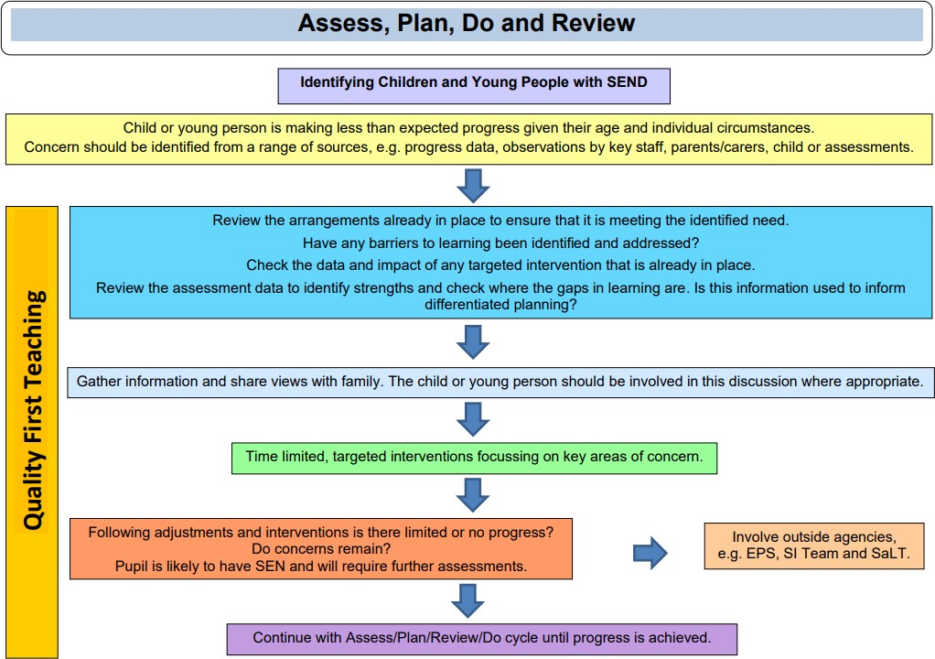 |  | 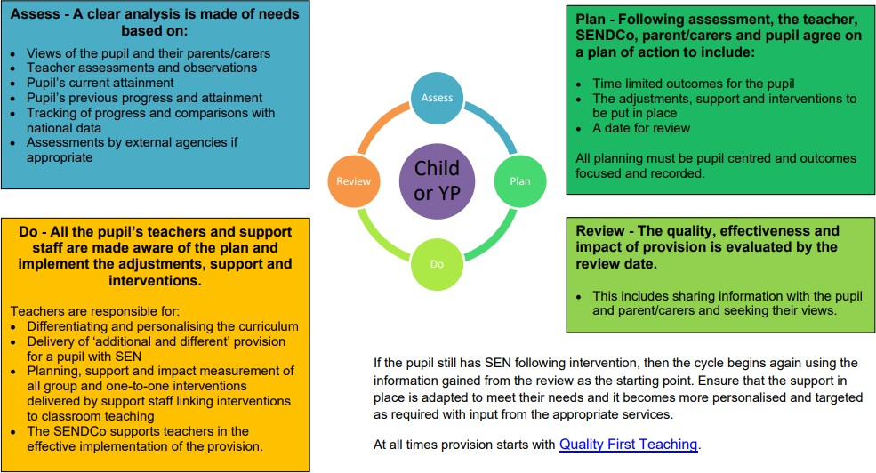
Our Graduated Response
Step 1
- Quality first teaching.
- Pupil progress meeting discussions.
- Reasonable adjustments made/identified for intervention as appropriate.
- Record concerns on Record My.
- Informal discussion with the Inclusion Team.
Class teacher to meet with Parents to discuss concerns
Step 2
- Inclusion team decide appropriate next steps. These could include:
  - Advice to class teacher
  - Intervention/reasonable adjustment identified by the Inclusion team
  - Initial Screen related to need e.g. SALT screen, dyslexia screen, sensory questionnaire etc
  - Child is added to the school SEND monitoring list
Class teacher to meet with Parents to discuss concerns
Step 3
- Inclusion team decide that it is appropriate to add the child to the SEND register
- Class Teacher to meet with parents to discuss continued concerns and adding their child to the SEND register.
- Identify primary need and secondary need if appropriate.
- Letter to parents to place the child on the SEND register (inclusion team to decide Stage 1,2 or 3 – this is for internal purposes only)
- Child added to SEND register as decided by the Inclusion Team.
- SEND Review Plan for stage 1, SEND Support Plan for stage 2 and both SEND Support Plan and Extended Support Plan for Stage 3
- Assess-Plan-do-review cycle, this should be run for at least one term.
Review internal School Stage 1,2 or 3 status on a termly basis or as necessary.
Step 4
Possible actions/support for each primary and/or secondary need could include:
SEMH | Cognition and Learning |  | Communication and Interaction | Sensory and/or Physical
Appropriate adjustments to QFT added onto SEND Class plan  ROAR Response 1:1 or small group intervention  Offer Early Help  Positive Handling Plan  CAMHs/CDC  Sensory profiling  Risk Assessment if appropriate  EPS | Appropriate adjustments to QFT added onto SEND Class plan  Bespoke Maths learning  Bespoke Writing learning  Access to phonics intervention  Dyslexia Screening  Dyscalculia Screening  EPS |  | Appropriate adjustments to QFT added onto SEND Class plan  SALT Traded Service  EPS  CAMHs/CDC  Social Stories  Sensory Circuits | Appropriate adjustments to QFT added onto SEND Class plan  Seek advice from specialist medical teams  Hearing Impairment service advice  Visual Impairment service advice  Medical Plan/Information  Risk assessment and/or PEEP (Personal Emergency Evacuation Plan)  EPS
Assessment Tool Used
Boxall Profiling  Sensory Profiling (if required) | Birmingham Toolkit |  | Entry and Exit Speech Screening  Sensory Profiling (if required) | Sensory Profiling (if required)
Step 5
Continued graduated response/Co-production with family. Additional actions/support could include:
SEMH | Cognition and Learning |  | Communication and Interaction | Sensory and/or Physical
MVP Access Resource Support  Aspire Outreach Support  ROAR Regulator Chart  Referral to Sensory Occupational Therapist  Positive Handling Plan | Fusion SEND HUB Advice  SEND Phonics Programme |  | Fusion SEND HUB Advice  Autism Communication Team referral  SALT external/ specialist Team  Referral to Sensory Occupational Therapist | Physiotherapy  Work alongside specialist medical teams as required  Referral to Sensory Occupational Therapist
Step 6
- EHCP
- Bespoke curriculum / learning based on EHCP outcomes / aspirations of the child / family
- Long term targets fed into Support Plans.
Review annually or in line with LA.
Impact
- No child is missed and all children have their provision regularly reviewed and monitored to ensure that it is purposeful, relevant and impactful and that the right children are identified for support from external agencies.
- Children are more swiftly identified as having SEND needs and appropriate support is put in place at the earliest point.
- We have well trained staff who are upskilled through close partnership working with external agencies and are therefore able to appropriately respond to need more effectively as evidenced through observations.
- The leadership team have an excellent oversight of SEND which allows for impactful strategic planning.
- EPS have had impact on EVERY SEND pupil across the school ensuring that QFT for SEND pupils remains strong and pupil needs are met.
- The children with the most complex needs have a bespoke curriculum and package of support.
- SEMH, ASD, ADHD and PDA Children have a greater ability to remain regulated or to regulate themselves more quickly when they do enter crisis.
- Assessment tools used allow for small steps of progress to be identified, tracked and celebrated, these also provide guidance to inform the next steps.
- The SALT pathway ensures that all children’s speech and language needs are screened on entry and any needs are rapidly identified and addressed through close consultation with traded service SALT.

