RSHE Policy
Updated for: | September 2025
Next review: | September 2026
Last parent consultation: | 23.09.25
Next parent consultation: | September 2026

James Montgomery Academy Trust

RSHE Policy
1. Statement of intent
Here at Meadow View Primary School, we understand the importance of educating pupils about relationships, sex and health education, in order for pupils to make well-informed and ethical decisions about their wellbeing, health and relationships. We have due regard for statutory guidance on RSHE and this, along with consultation, has steered the development of this policy.
RSHE in our school plays a vital role in pupils’ lifelong learning about moral, social, cultural, mental and physical development. RSHE, taught alongside and within the PSHE curriculum, aims to give pupils and young people essential skills for building positive, enjoyable, respectful and non-exploitive relationships and the skills to stay safe both on and off line. It enables pupils to explore their own and other’s attitudes and values and builds their self-esteem and confidence.
The DfE ‘Sex and Relationship Education Guidance’ defines this programme as: “Learning about physical, moral and emotional development; understanding the importance of marriage for family life, stable and loving relationships, respect, love and care. It is also about the teaching of sex, sexuality and health.”
The programme will be taught objectively and does not promote any form of sexual orientation or sexual activity. This policy reflects the statutory RSHE & Health Education guidance with implementation from Autumn 2025. The James Montgomery Academy Trust supports early adoption of the updated guidance.
2. Aims and objectives
RSHE is an opportunity for pupils to:
- Develop an age-appropriate understanding of relationships and where Sex Education is taught, an understanding of human reproduction in line with the Science National Curriculum.
- Develop a range of personal and social skills.
- Understand how to keep themselves safe and healthy
These aims are met through an age-appropriate, inclusive, and progressive curriculum.
3. Statutory guidance
At Meadow View Primary School, we teach RSHE as set out in this policy. The Department for Education made Relationships and Health Education compulsory for primary pupils and Relationships, Health, and Sex Education compulsory for secondary pupils from September 2020. This policy adheres to the following:
- DfE RSHE Guidance (updated July 2025)
- Keeping Children Safe in Education
- DfE Science Programmes of Study: Key Stages 1 and 2
4. RSHE in the curriculum
Meadow View Primary School uses Kapow to teach both our PSHE and RSE. The two topics are intertwined Attached as Appendix 3 is the guidance for parents which explains what is what the statutory requirements are for each year group, how they are taught and tips on how to help at home.
RSHE is developed in conjunction with the views of staff, pupils, and families in line with DfE recommendations.
Lessons are mainly delivered through the PSHE curriculum, with some statutory components covered in the Science curriculum.
In line with the updated RSHE guidance:
- The school will not teach about different forms of sexual activity or gender identity.
- Teaching about the risks of online gaming, social media, and scams will not occur before Year 3.
- Puberty education will begin no earlier than Year 4.
- Conception and birth will only be taught from Year 5 onwards, in line with the Science curriculum.
Parents can request to see all teaching materials and have the right to withdraw their child from sex education beyond the National Curriculum for Science.

Please see Appendix 4 for information around where the statutory aspects of RSE are taught in our curriculum.

5. Training of staff
Staff involved in RSHE delivery will receive regular training in line with curriculum updates, statutory changes, and identified CPD needs. RSHE leads will support with planning and resource development.

6. Delivery of the RSHE in the curriculum
RSHE may be taught in single-gender or mixed groups, depending on the topic. Resources such as videos, books, and discussions will be used with sensitivity to age and cultural backgrounds.
Safeguarding controls prevent pupils from accessing inappropriate content online, as detailed in the JMAT Online Safety Policy.
Staff will encourage discussion, listen to pupil views, and answer questions within curriculum scope. Questions outside the taught content will be referred to parents or a trusted adult.
RSHE will be inclusive of all pupils, including those with SEND, and adapted appropriately.

7. Working with families
We recognise some RSHE topics may cause concern for families. Our approach includes:
- Regular consultation with families (e.g. surveys, open evenings, meetings).
- Clear communication about curriculum coverage.
- Opportunities for parents to view resources.
Parents have the right to withdraw children from sex education lessons that are not part of the National Curriculum for Science.

8. Equal opportunities
RSHE will be delivered in accordance with the Equality Act 2010, ensuring all pupils are treated with dignity and respect. Teaching will be inclusive and recognise the diversity of families, including LGBTQ+ families, single-parent families, and families with different faith or cultural backgrounds. Lessons will be age-appropriate, sensitive, and free from bias or discrimination. All pupils will be encouraged to understand and respect differences, fostering an inclusive school community.

9. Confidentiality
Confidentiality is maintained in the classroom where possible. However, any disclosures related to safeguarding concerns will be reported in line with the JMAT Safeguarding Policy.

10. Child on Child abuse / bullying incidents
JMAT has a zero-tolerance approach to child-on-child abuse and bullying. Incidents related to RSHE will be dealt with in line with our Anti-Bullying and Safeguarding policies. Serious incidents may be reported to external authorities.

11. Monitoring and review
This policy is reviewed annually by the Senior Leadership Team and RSHE Lead. Monitoring includes:
- Reviewing feedback from parents, staff, and pupils.
- Lesson observations and resource reviews.
- Staff training records.
Changes will be communicated to all stakeholders.

12. Document history

Previous versions now deleted from system

Issue | Author/ Owner | Date  Reviewed | Reviewed  by | Approved by  A&R Committee  (date) | Comments/ Changes
V1 | JMAT | July 2025 | PRG | 08/07/25 | - Section 8 – updated wording.  - Some minor word changes to ensure compliance with updated guidance (July 2025).

Key:
PRG – Policy Review Group
A & R Committee – Audit and Risk Committee

Appendix 1
Science National Curriculum
In accordance with the DfE’s ‘Sex and Relationship Education Guidance’ 2000, there are certain aspects of sex and relationship education which are compulsory for pupils to learn as they progress through the key stages.
Key stage | Pupils must be taught:
Key stage 1 | - Identify and name main external body parts.  - Recognise that animals (including humans) reproduce.  - Understand how humans grow from babies into adults.
Key stage 2 | - Describe the changes as humans develop to old age.  - Understand human reproduction and development.

Appendix 2
Age restrictions for topic content:
- No teaching about gender identity.
- No additional sex education beyond the National Curriculum for Science, unless parents are consulted and withdrawal rights are explained
- No online harms content before Year 3.
- No puberty before Year 4.
- No conception/birth content before Year 5.

Appendix 3
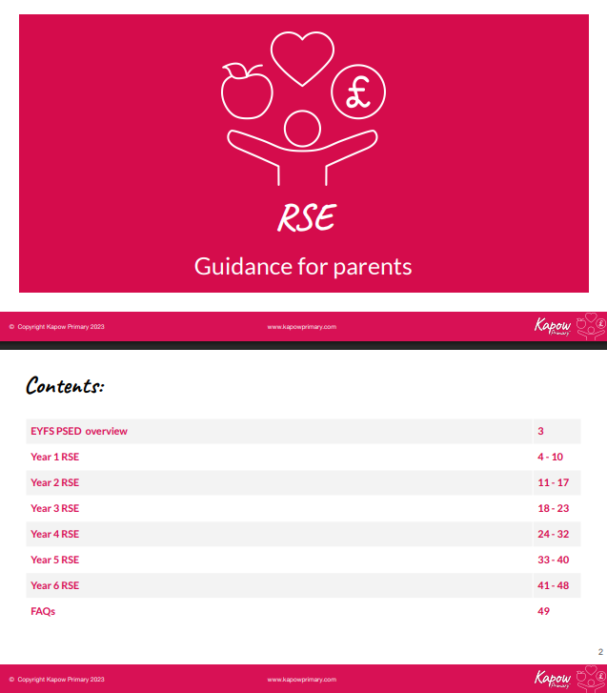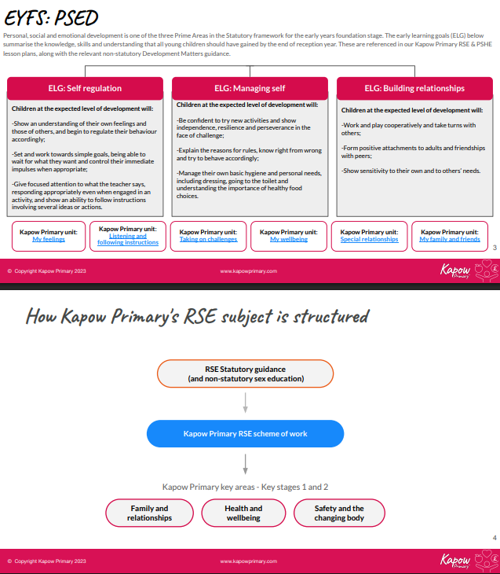

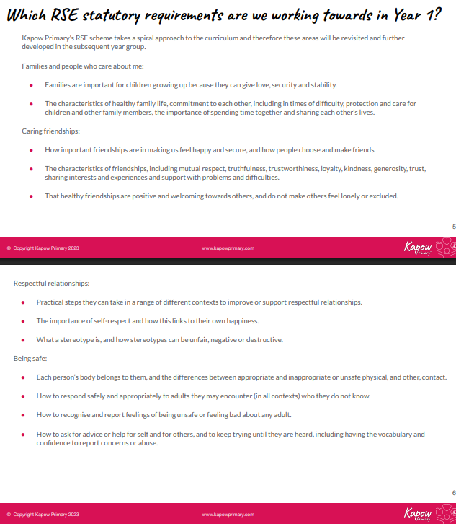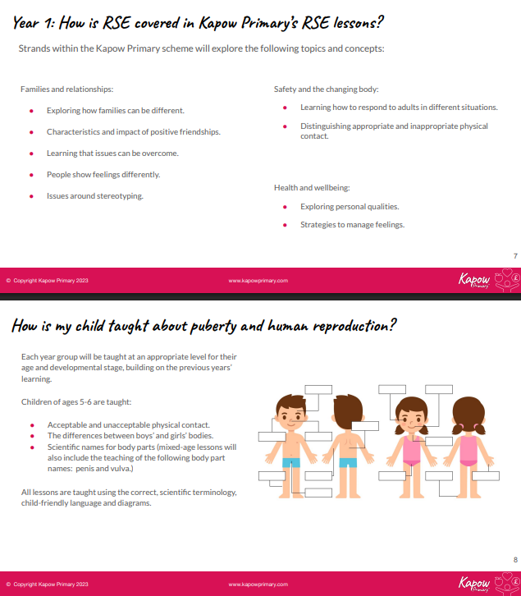

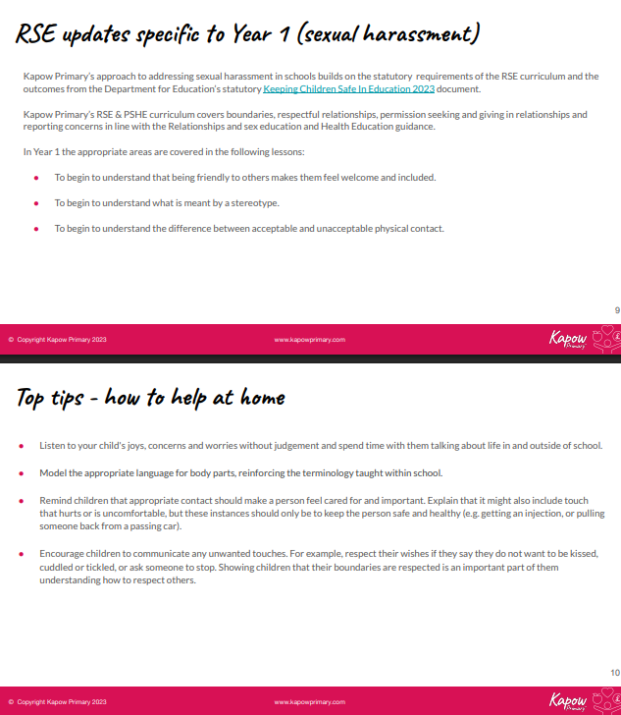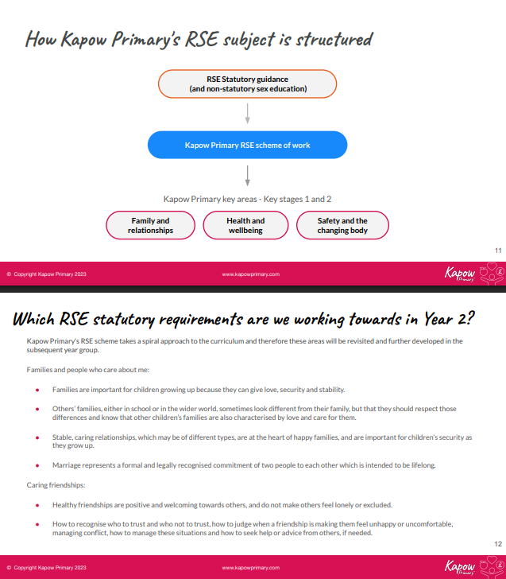

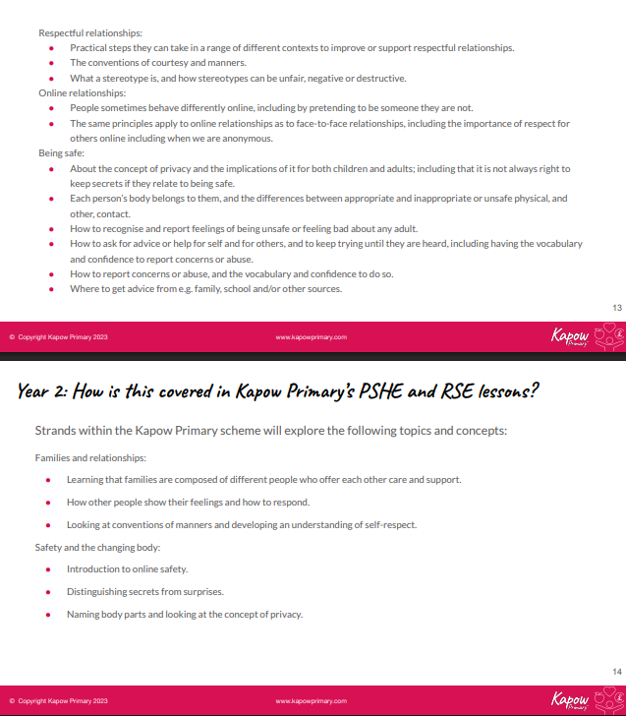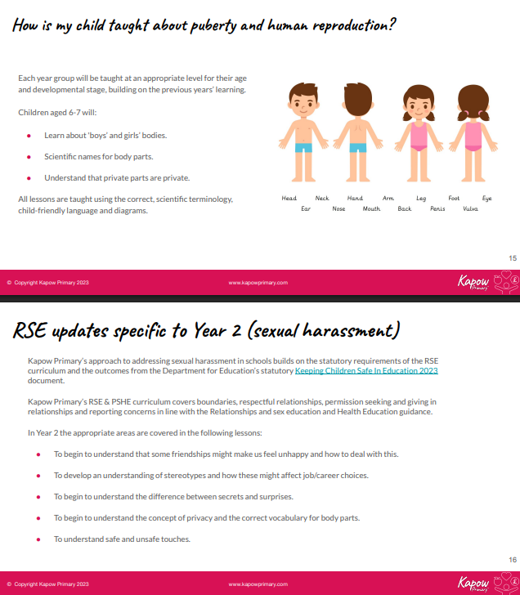

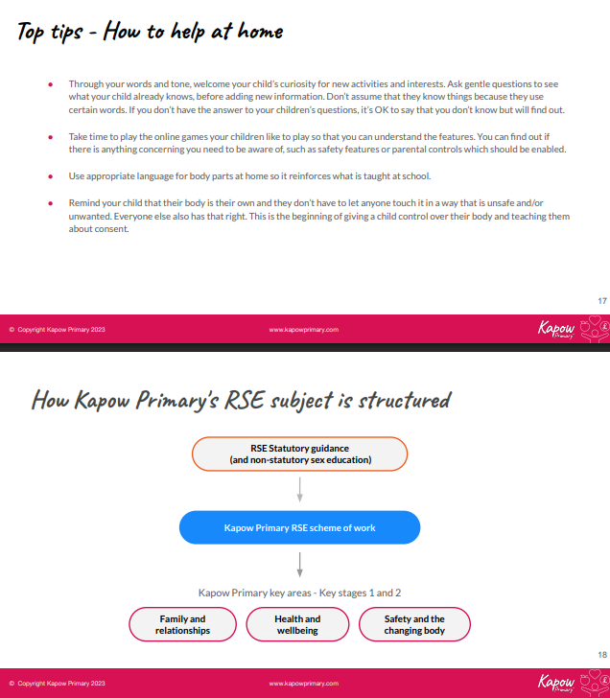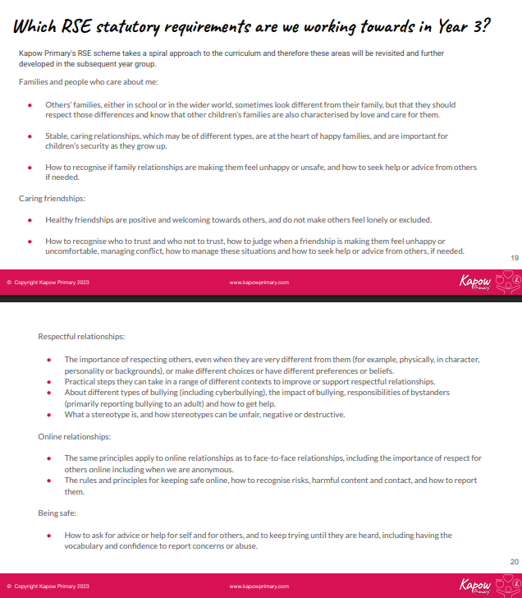

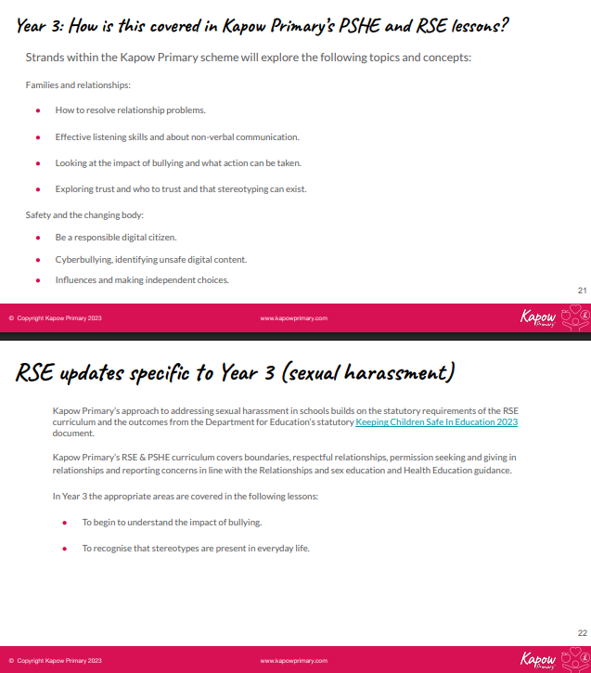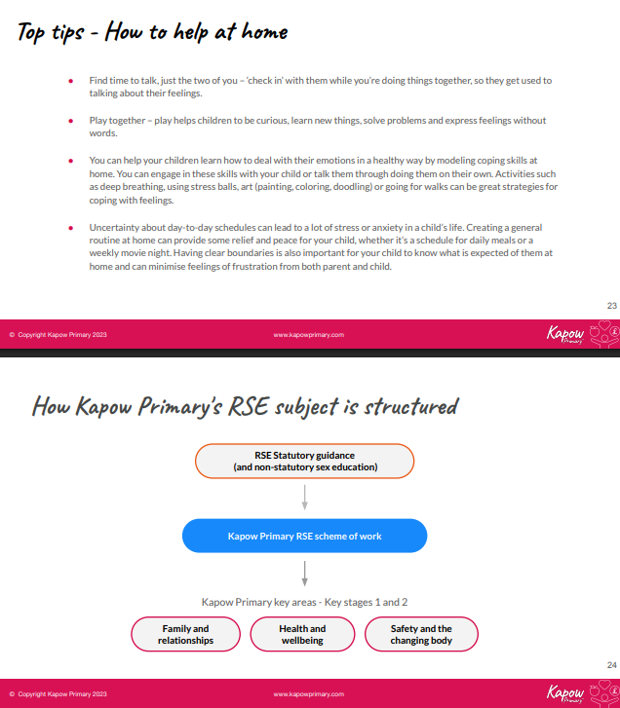

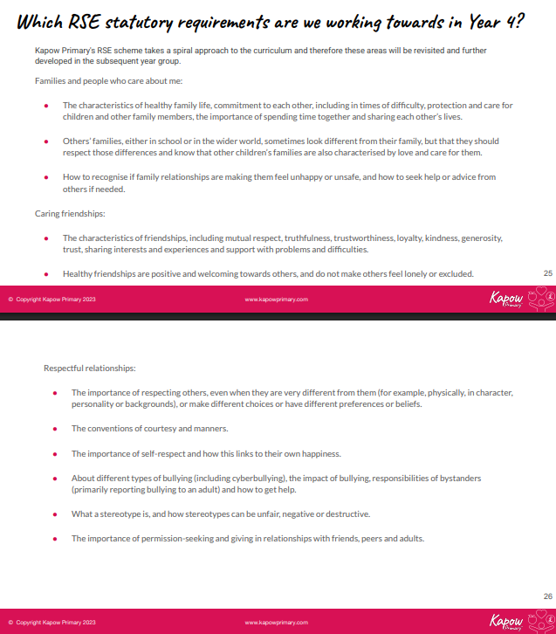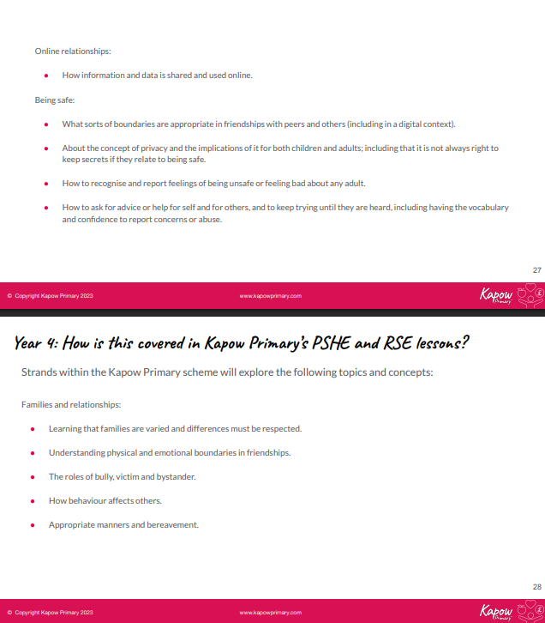

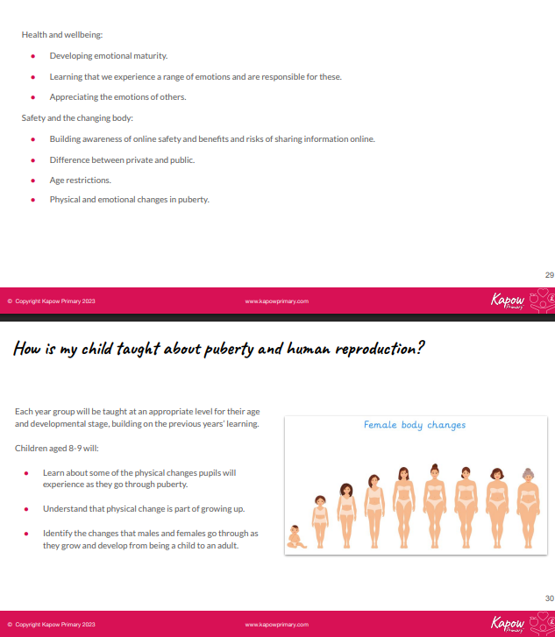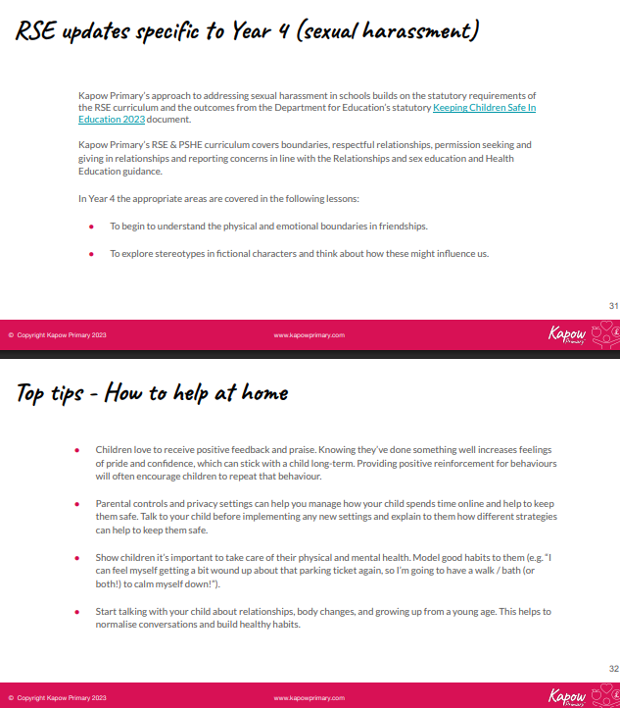
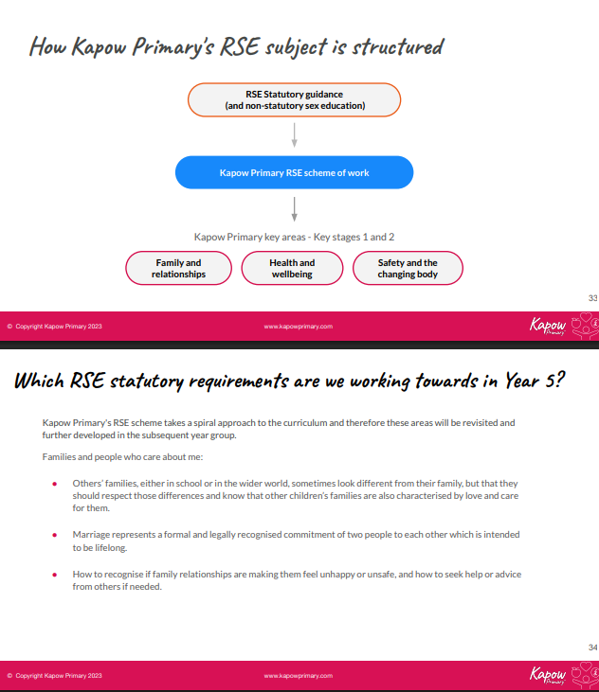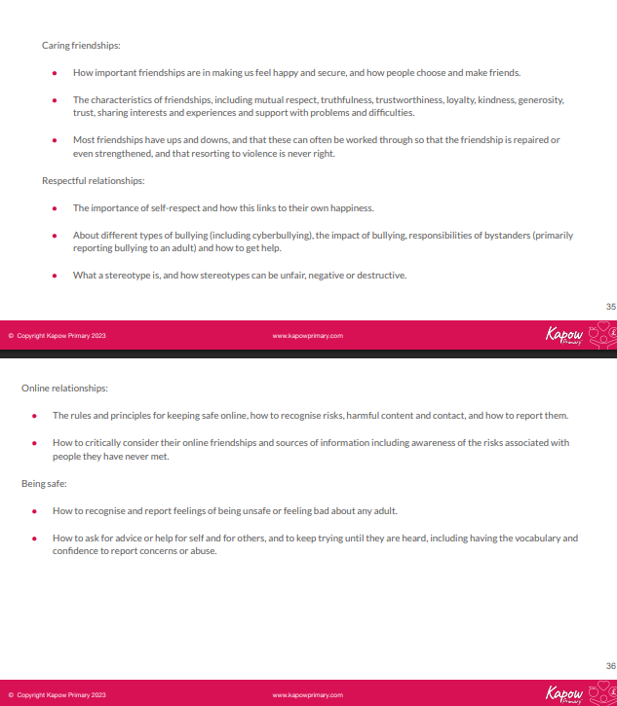

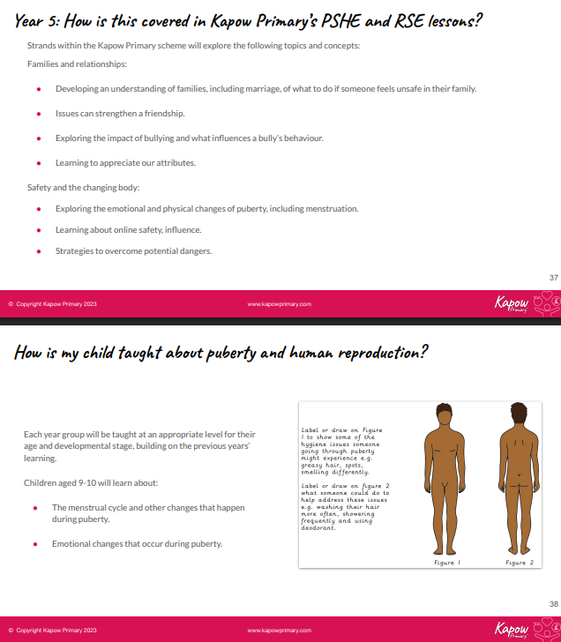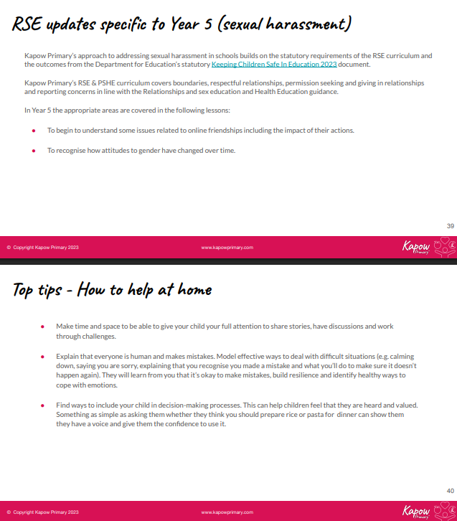

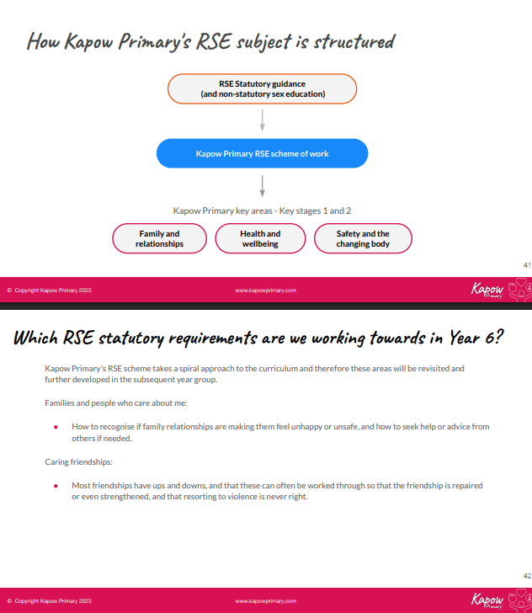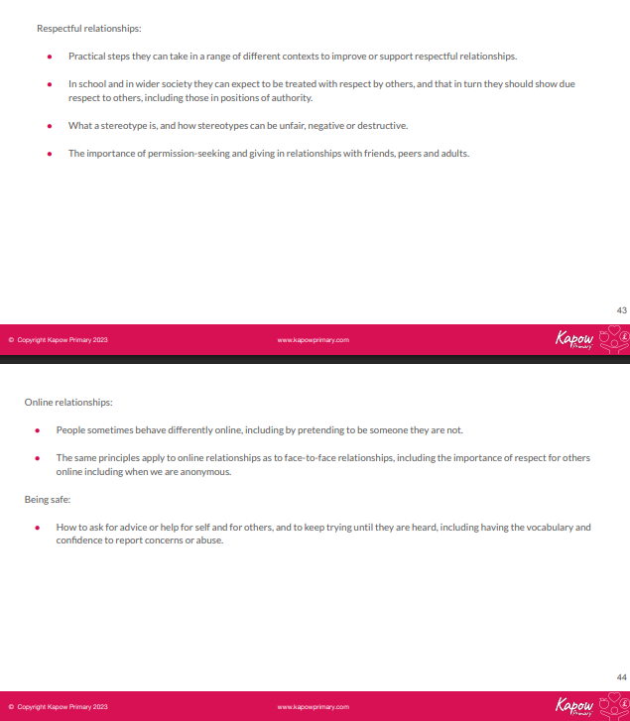

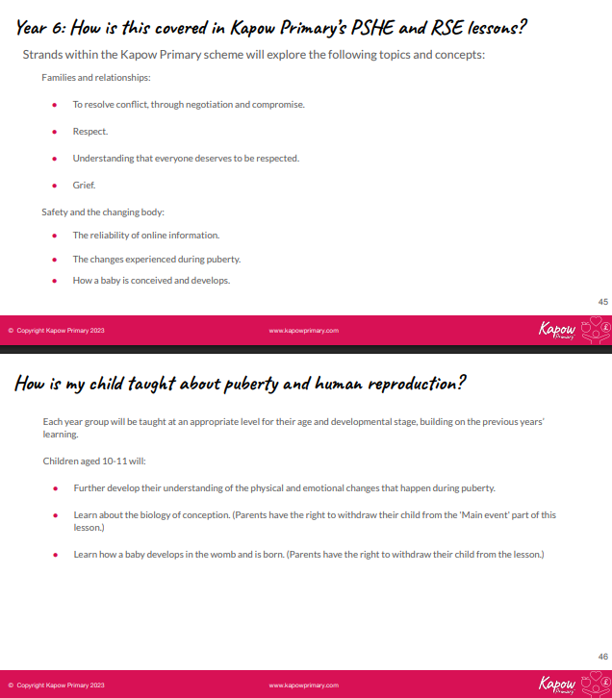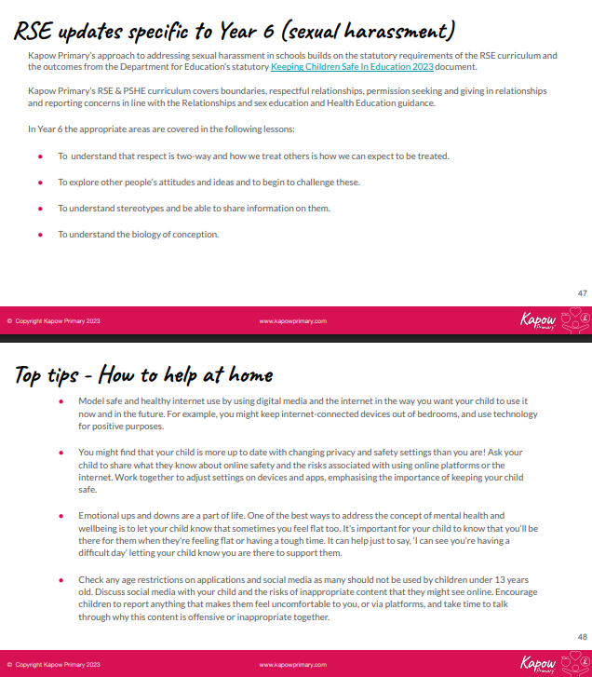

Appendix 4
